You’re invited to attend the
Waterloo Biofilter Nova Scotia 2024 Seminar
April 12th 2024, 7pm- 9pm

Best Western Truro – Glengarry
150 Willow Street
MacLeod AB Room
Truro, NS
B2N 4Z6

Waterloo Biofilter seminars bring together a network of installers, designers, regulators and others within the wastewater industry. The focus is on Waterloo residential and commercial systems with a brief overview of system service and maintenance.

Some of the topics at this year’s seminar include:
- 2024 Updates
- Waterloo’s Competitive Advantage
- Residential and Commercial Installations
- Ordering
- Maintenance

Feel free to pass this invitation along to your local regulators and designers.
We look forward to seeing you!
Please click the appropriate Eventbrite link below for who you wish to register your office and field staff for. The password is Waterloo.
https://www.eventbrite.ca/e/waterloo-biofilter-nova-scotia-2024-seminar-tickets-869373317997
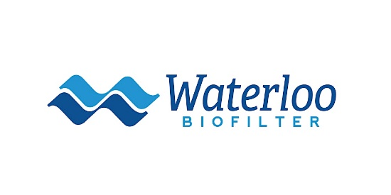 | Waterloo Biofilter Nova Scotia 2024 Seminar  Eventbrite - Waterloo Biofilter presents Waterloo Biofilter Nova Scotia 2024 Seminar - Friday, April 12, 2024 in Truro, NS. Find event and ticket information.  www.eventbrite.ca

